Football Transfers in the Last 100 Years

# Authors:

Asger Brylle Sørensen, Sejer Bo Christensen, Laurits Halldorssøn Johansen, Nikolaj Nørgaard Vørstein

# Keywords: Football, Transfer Fees, Economic development

# Abstract

In recent decades, football has seen transfer fees rise to staggering heights. How did we get here? This project analyzes the historical trajectory of football transfer fees over the last century, with a special focus on economic fluctuations, global crises, financial globalization, and other historical events. Using data scraped from Transfermarkt.de and GDP figures from the World Bank, we used digital tools like RStudio and ggplot2 to visualize and interpret long-term economic trends and patterns in football. Our results show a striking increase in transfer fees from the 1990s onward, often exceeding growth in global GDP. Major historical events such as the Second World War, the 2008 financial crisis, and the COVID-19 pandemic impacted football transfer fees, but aside from these, transfer fees are only loosely connected to global economic developments. This study illustrates how digital methods can be used in historical economic research and helps us understand how the world’s most popular sport has developed economically over the last century.

A - Main Report

# Introduction

## Problem Orientation and Motivation

We aim to explore the global economy of football transfers over the past 100 years. Today, transfer fees in football have reached staggering levels. In 2017, Neymar da Silva Santos Júnior transferred from FC Barcelona to the Qatari-owned French club Paris Saint-Germain for €222 million (approximately DKK 1.6 billion). That amount rivals the cost of large state-funded infrastructure projects. It seems almost surreal that a single individual could be worth such a fee purely based on their ability to play football.

Our research investigates whether this has always been the case and how economic trends in football have evolved.

We encountered fewer historical challenges than expected. However, we did need to consider major economic disruptions such as the 1973 oil crisis, the 2008 financial crisis, and most recently, the COVID-19 pandemic, which began in 2020 and had a significant impact on football worldwide. The most disruptive period, however, was likely the Second World War, during which most football activities and transfers were put on hold.

Culturally, many factors have influenced the football economy. In recent years, oil-backed ownership from the Middle East has increasingly dominated the global football market. These actors have had a dramatic impact on the industry, largely due to investments in football development in the region and efforts to present these countries in a more favorable light internationally—most notably demonstrated by the FIFA World Cup in Qatar in 2022.[1]

Some of the central questions driving our research include:

* How have transfer fees in football evolved?
* Do the most expensive transfers each year reflect broader global economic trends?
* Does an international economic crisis impact the economics of football transfers?
* What other historical, political, or cultural factors have influenced the football transfer market?

## Background /Context

Football has, over the last century, become the most popular sport in the majority of the world’s countries. Humanity has always found ways to kick a ball, whether made from stone or other materials, but what we recognize today as modern football was first developed in England in the mid-19th century[2]. Since then, the sport’s cultural and especially financial dimensions have changed dramatically. As football professionalized throughout the 20th century, its economic aspects evolved significantly, particularly with respect to player transfer fees. But how much, and why, has this changed over time?

We were originally intrigued by this research question when we read that the ticket price for a top-flight match in England had become more expensive and less accessible. A report from History and Policy suggests that “Between 1989 and 1999, Premier League ticket prices rose by 312%, in a period when the retail price index increased by 54.8%.”*[3]* This information, combined with what we observed to be consistently increasing investment in the sport, led us to investigate the long-term economic development of football—and in particular, its transfer fees.

Our goal is to examine how transfer fees have evolved over a full century and to identify the economic, historical, and cultural factors that have driven these changes. By studying the ten most expensive transfers from each season since 1924, we aim to map football’s economic and financial development and to assess whether it aligns with global economic trends.

## Expectation / Hypothesis

In our research, we expect to find several key patterns in the development of football transfer fees.

First, we expect to see an exponential rise in transfer fees over the last 100 years. With the advancement of technology, including global broadcasting, digital marketing, and the overall commercialization of football, we anticipate a steep increase in transfer fees. Furthermore, in recent years, we have seen the rise of extremely wealthy owners, particularly from the Middle East, and the spread of multi-club ownership, both of which have contributed to an environment of inflated prices.

Second, we expect to observe a general upward trend in the monetary value of football transfers over time, reflecting the sport’s commercial growth. In parallel, we also expect to see a broad upward trend in global economic performance, as indicated by GDP development. However, we predict that football transfer data will show greater volatility than global GDP, due to the smaller dataset and the influence of sport-specific factors such as high-profile transfers and competitive ambitions.

Third, we expect to identify a correlation between major economic crises and a downturn in football transfer spending, likely mirrored in reduced transfer activity.

Finally, we anticipate that during wartime—particularly during the Second World War—there was significantly less activity, as global conflict would have disrupted both the sport and financial transactions.

# Methods

1. **Research Design:**

To investigate the development of football transfer fees over the past 100 years, we adopted a quantitative, nomothetic research approach. This approach allowed us to identify general trends and patterns over time rather than focusing on individual cases. Our primary dataset was compiled from publicly available data on Transfermarkt.de, which includes historical transfer fees across different periods. We manually converted this data into a structured CSV file for analysis.

Using MacBooks as our working platforms, we imported the dataset into RStudio, where we used the ggplot2 package to create visualizations of transfer trends. This helped us analyze how economic, historical, and cultural events have influenced transfer activity and price levels.

1. **Software Framework and Materials:**

We wrote the code for this project on four different MacBooks: Nikolaj used a MacBook Pro (13", M2, 2022) running macOS Monterey Version 12.5.1; Sejer used a MacBook Air (13-inch, Mid 2013) with macOS Big Sur Version 11.7.10 (20G1427); Laurits used a MacBook Pro (13-inch, 2017) with macOS Ventura Version 13.6.9; and Asger used a MacBook Air (M2, 2022) with macOS Sonoma Version 14.6.1. We worked primarily in R using RStudio and relied on the packages tidyverse for data manipulation and visualization, and ggplot2 for creating our plots. No cloud-based solutions were required for reproducing our results.

1. **Data Acquisition and Processing:**

<https://www.transfermarkt.com/statistik/saisontransfers> → To track the development of football transfer fees over the last 100 years, we used data from Transfermarkt.de. The site provides one of the most comprehensive overviews of global transfer activity, offering season-by-season data on transfer fees. This makes it especially useful for identifying trends in transfer fee amounts. However, there are some limitations:

* Transfermarkt.de relies partly on estimated values, particularly for older transfers, which may reduce accuracy. Today, transfers are regulated by FIFA, UEFA, and domestic football associations (e.g., DBU in Denmark and FA in England).
* Additionally, the site focuses primarily on men’s football, limiting comparative data with women’s football.
* Finally, although Transfermarkt.de is a respected and commonly cited resource, it is not an academic or peer-reviewed source, which may result in inaccuracies, especially regarding early transfers.
* Despite these issues and limitations, it remains a valuable tool for analyzing long-term trends in the football economy. Transfermarkt.de is widely considered the best and most reliable source for historical football transfer data, as it uses data from clubs, FIFA reports, media outlets, and experts, offering one of the most complete archives of global transfers available to the public. As Helle Strandgaard notes in her article *Digital Archival Literacy for (all) Historians*: “Nevertheless, they are essential to study.”[4]

**Our streamlining process before using RStudio:** We examined <https://www.transfermarkt.com/statistik/saisontransfers>. We reviewed every single “season” from 1924/1925 onward and recorded the ten most expensive transfers into an Excel spreadsheet. From this, we calculated the average of the ten biggest transfers for each season. The Excel file was then converted into a CSV file, which we imported into RStudio.

<https://data.worldbank.org/indicator/NY.GDP.MKTP.CD> → We also used the World Bank to collect data on global GDP growth from 1960 to 2023.

The reasoning behind this choice is straightforward: the World Bank, established in 1944, tracks the world’s economic development. For this reason, it is the most accurate and widely used source for this type of data.

**Our streamlining process before RStudio:** We extracted data from the World Bank website, receiving a CSV file with values for every country, continent, income group, and organization (e.g., OECD). We then used ChatGPT to create a CSV file based on the combined global GDP data shown in the World Bank graph. We cross-checked the information for accuracy and converted it from USD to EUR to match the currency used for transfer fees.

# Findings

## Presenting our findings

Our analysis of football transfer data over the past century shows a clear and consistent upward trend in transfer fees, especially from the early 1990s onward. Using visualizations created in RStudio with the ggplot2 package, we observed that both the frequency of high-value transfers and the amounts involved have increased significantly over time.

These visualizations highlight key patterns, such as the consistent breaking of transfer fee records and the growing number of transfers involving large fees. These patterns suggest that the value placed on top players has steadily increased, and that football clubs are increasingly willing to invest heavily in talent to gain competitive advantages and commercial success.

Furthermore, we explored potential connections between football transfer trends and the wider global economy. We created an additional graph in RStudio using the ggplot2 package to illustrate the development of global GDP from 1960 onward. By comparing the rise in transfer fees with overall economic growth, we aimed to investigate whether increases in football spending reflect larger economic trends over time. This comparison helps evaluate the evolution of the football transfer market in relation to the global economy.

To further support this inquiry, we focused on specific global economic disruptions: the 1973 oil crisis, the 2008 financial crisis, and the COVID-19 pandemic in 2020. To better assess the trends, we calculated the year-over-year percentage change in both football transfer fees and world GDP.

## Illustrations

### Figure 1: Average Transfer Fees Over Football Seasons (1924-2023)

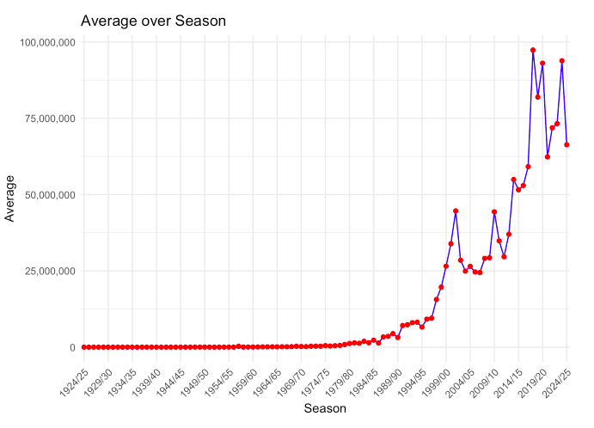

*This graph shows the average football transfer fee per season from 1924/25 to 2024/25. The red dots mark each season’s average, connected by a blue line to show the trend.*

*The sharp increase starting in the mid-1990s corresponds with the commercialization and globalization of football. The upward surge intensified after 2010, peaking just before 2020, when Middle Eastern investment began intensifying and average transfer fees approached €100 million. This reflects a growing influx of capital into football, especially driven by TV rights, sponsorships, and foreign investments. [5]*

### Figure 2: World GDP Development (1960–2023):

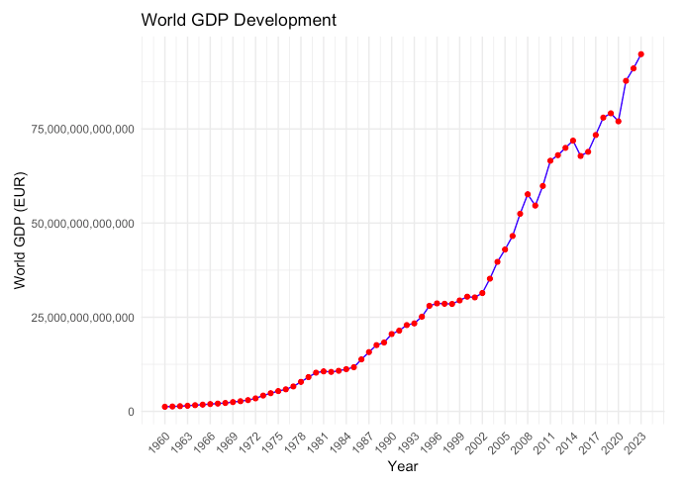

*This graph represents the global GDP in euros over more than six decades, with red points showing actual yearly GDP data connected by a blue line for visual clarity.*

*If presenting, point to the steady upward slope with marked acceleration after 2000, representing global economic growth driven by technological advances, international trade, and development in emerging economies. Despite occasional dips (such as around 2008 and 2020), the overall trajectory is upward.[6]*

### Figure 3: Comparison of Football Transfer Fees and World GDP in € (1960-2023)

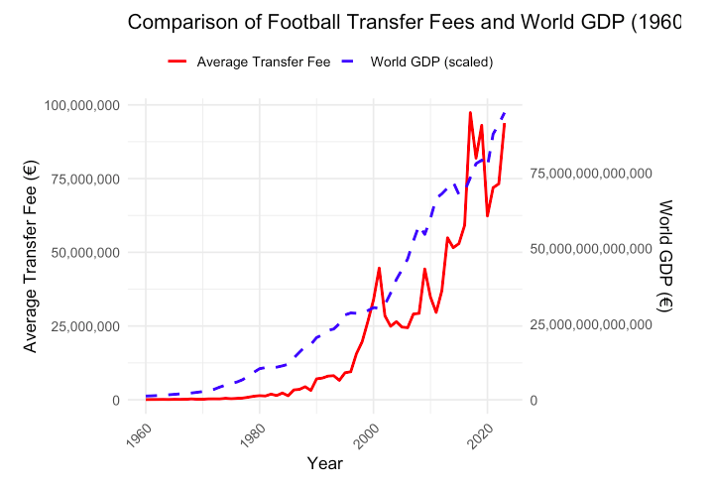

*These two graphs compare average football transfer fees (red line) with scaled world GDP (blue dashed line) over time. The right y-axis corresponds to GDP in euros, while the left y-axis shows average transfer fees, also in euros. While both trends rise, the transfer fees begin increasing more steeply from the late 1990s, outpacing the more gradual increase in GDP. A pointer would help highlight how football transfer fees appear to grow disproportionately faster than world GDP, especially in the 2010s and beyond.*

*It is important to notice that these two graphs are not directly comparable, and that the data values are different on each side of the y-axis.*

### Figure 4: Crisis Years vs Transfer Fee and World GDP % Changes (1960-2023)

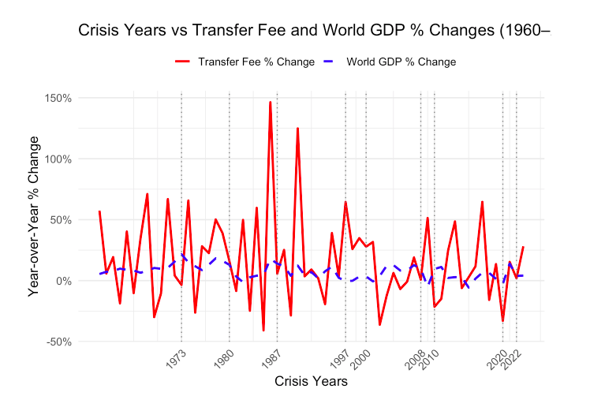

*This graph compares the year-over-year percentage change in average football transfer fees (red line) with changes in world GDP (blue dashed line) from 1960 to 2022. Crisis years such as* ***1973*** *(First Oil Crisis),* ***1980*** *(Second Oil Crisis),* ***1987*** *(Stock Market Crash),* ***1997*** *(Asian Financial Crisis),* ***2008*** *(Financial Crisis),* ***2020*** *(COVID-19 pandemic), and* ***2022*** *(Energy Crisis) are marked with vertical dashed lines.[7]*

*There are major differences between the two curves: the blue line representing world GDP changes follows a relatively stable and predictable pattern, while the red line, tracking football transfer fee, has far greater fluctuation.*

*World GDP changes tend to reflect major global trends, showing clear slowdowns during crises like the 1973 oil shock, 2008 financial crisis, and COVID-19 pandemic, followed by gradual recoveries. In contrast, football transfer fees are far more unpredictable, often spiking or dropping for reasons unrelated to the global economy. However, the football transfer fees show an alignment with the world GDP after the financial crisis in 2008 and the COVID-19 pandemic in 2020, where there is a clear drop in percentage from the year before. Whether this trend is the result of the general economic situation or heavily influenced by internal football affairs, such as high-profile transfers, sporting ambitions, ownership changes, or competitive pressure, is uncertain.*

*The blue GDP line reflects a general economic reality, while the red transfer fee line reflects a niche market.*

#### **Figure *4.1: Comparison of Football Transfer Fees and World GDP (1960-2023)***

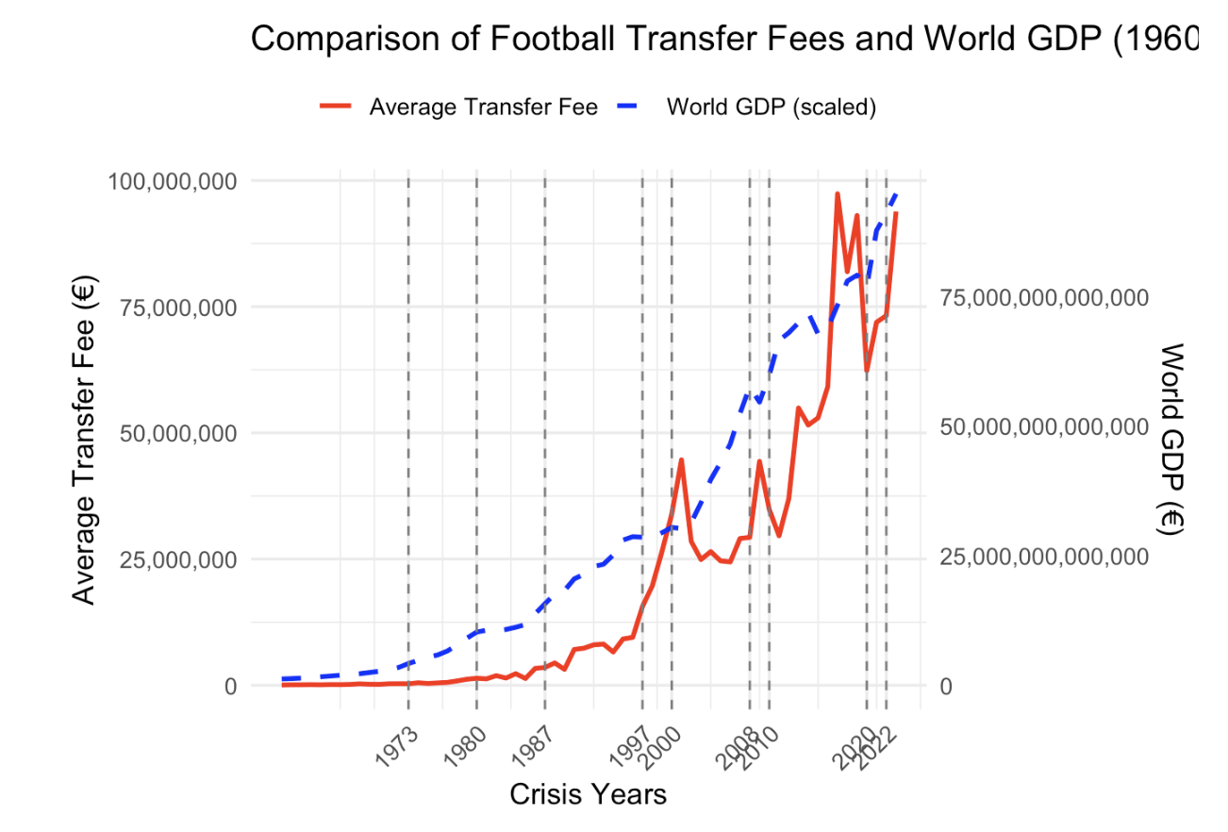

*This graph illustrates the long-term development of average football transfer fees (in red) alongside global GDP (in blue, scaled for visual comparison) from 1960 to 2022, with key global crisis years marked by vertical dashed lines. It is essentially the same as figure 3.0, but with the X-axis only representing the Crisis Years. You can observe the graph around the crisis in 2008 and 2010, and see a clear correlation between transfer fees and the world GDP, as both take a dip and recover just the same.*

### Figure 5: Early Period: Average over Season (1924/25 - 1956-57)

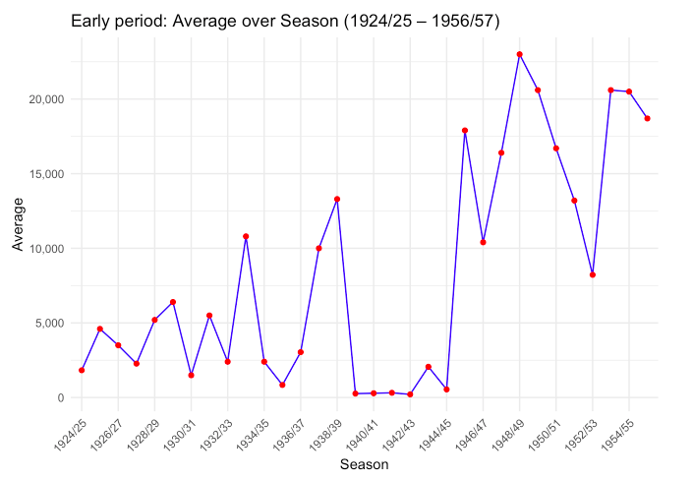

*This chart illustrates the average football transfer fee per season during the early period of professional football, from the 1924/25 season to 1955/56. The vertical axis shows the average fee, while the horizontal axis tracks each season chronologically.* ***Disclaimer****: We have elected to exclude the 1956/1957 season because it includes a major outlier that does not represent the trends in that elected period as "Early period", or for that matter, not even the "Middle period".*

*As you can see from the graph, there is a notable drop in transfer activity during World War II (1939–1945) and an obvious huge boom at the end of the war.*

### Figure 5.1: Early period: Percent Change (1924/25 - 1956/57)

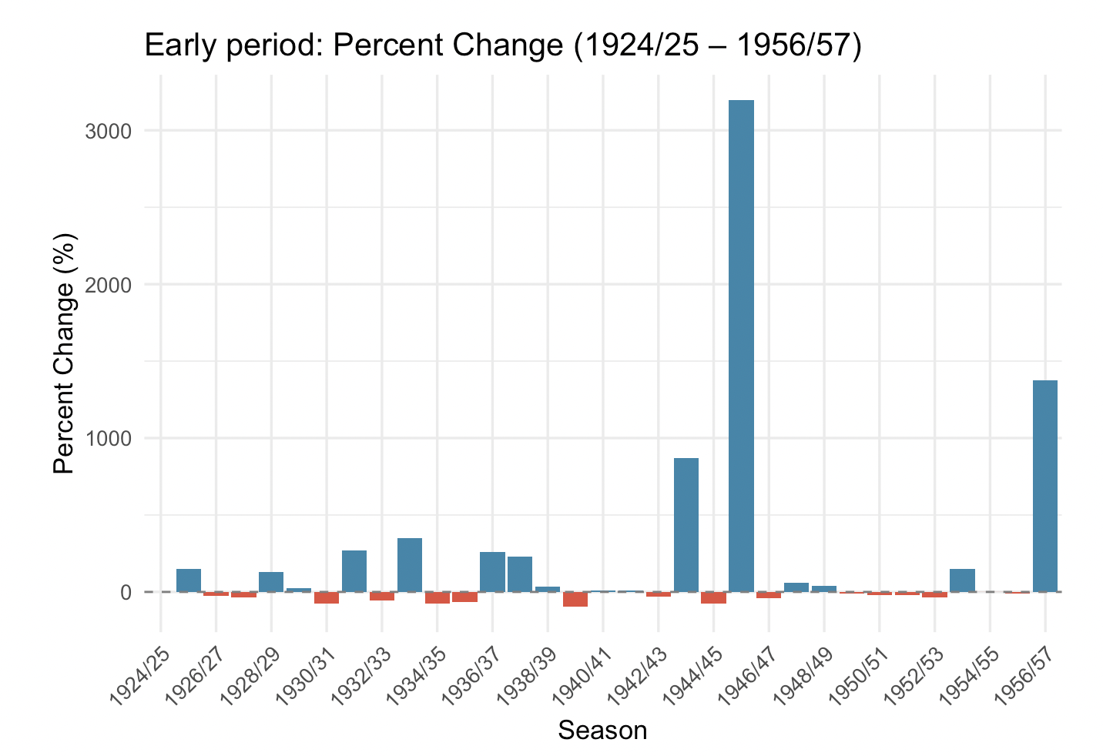

*We have also made a graph that shows the percentile change between seasons, so we can analyze the growth or fall per season easier. Like in Figure 5.0, there is a significant rise in the average transfer fee in the 1945/1946 season, just after the Second World War, and it has the highest growth in all our observations of well over 3000% (3196,50%). This happens since the transfer fees during the Second World War is near €0, so even though the transfer fees during 45/46 is not high it looks extreme compared to the previous season.*

### Figure 6: Statistics

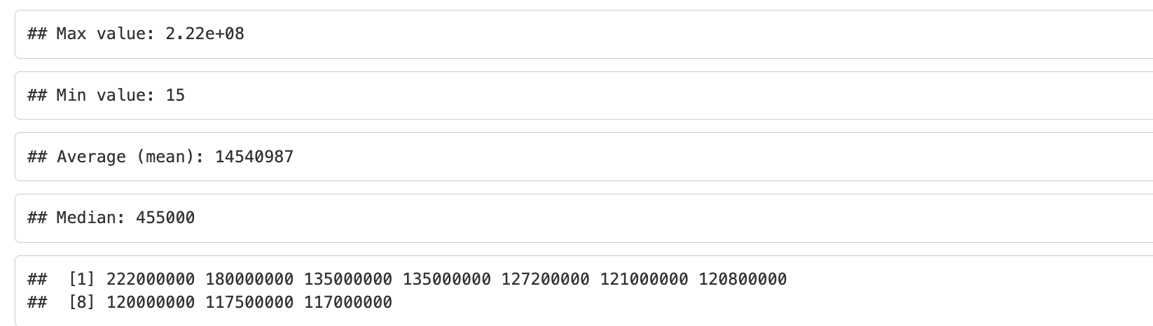

*Figure 6 shows a basic statistical summary data for a dataset of numerical values.*

* *Maximum Value: 222,000,000 — the highest number in the dataset.*
* *Minimum Value: 15 — the lowest number in the dataset,*
* *Average: 14,540,987 — the sum of all values divided by the number of entries. This is significantly skewed by the extremely large maximum value.*
* *Median: 455,000 — the middle value when the numbers are sorted. Since it's much lower than the mean, this suggests a few very large numbers are skewing the average upward.*
* *Top 10 Transfers - the ten biggest values in the entire dataset*

### Figure 7: Modern period: Average over Season (1990/1991 - 2024/2025)

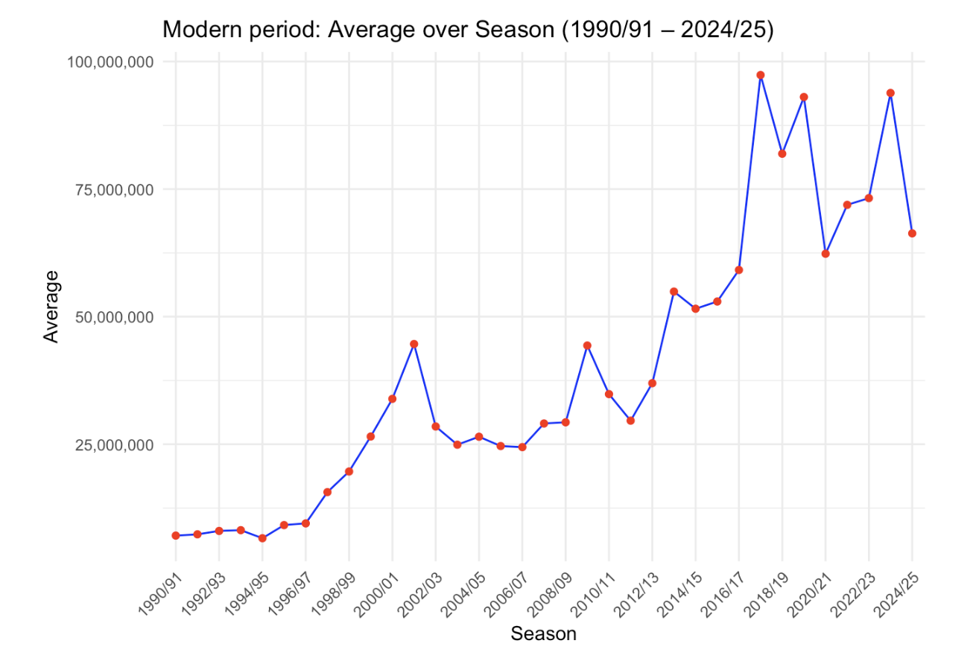

*To end of this segment, we have a graph showing the average transfer fee value during the modern period. As mentioned before, we started to see a steep increase in transfer fees during the mid 1990’s. The transfer fees see a peak during the 2017/2018 season, hitting an average of almost €100 million, while fluctuating a bit afterwards.*

# Discussion of Results / Critical evaluation.

## Significance of findings

Our central research questions were:

1. How have transfer fees in football evolved?
2. Do the most expensive transfers each year reflect broader global economic trends?
3. Does an international economic crisis have an impact on the economics of football transfers?
4. What other historical, political, or cultural factors have influenced the football transfer market?

Based on our results, we can see clear answers, especially for Question 1 and 4. These are more straightforward, with fewer variables involved, and the datasets were easier to organize and work with. Questions 2 and 3 were more complex, as they included a wider range of elements and required input from different data sources and literature.

Looking at the first question, “How have transfer fees in football evolved?”, it is clear that transfer fees have steadily increased since our first recorded data in 1924. Figure 1 shows a significant surge occurred during the 1990s, and this upward trend continued until just before 2020. The sharp decline that followed was largely a result of the COVID-19 pandemic. In recent years, however, transfer fees have returned to a more typical pattern of growth, as they continue to rise. The massive investments in football in recent times are also a subject of newfound economic interest from Middle Eastern countries, e.g. Saudi Arabia and Qatar, and with signings like Neymar to Qatari-owned PSG and a heavily funded Saudi League, they have introduced a new agenda in global football.[8]

The graph comparing World GDP % change with transfer fee % change (figure 3) shows a shared general upward movement, especially post-1990. However, it also confirms our prediction that football data is more volatile. Transfer fees spike and drop dramatically year to year, whereas GDP follows a much smoother, more stable curve. This highlights that the football economy is less predictable, even though it tends to rise.

Contrary to our initial hypothesis, the data does not show a consistent pattern between global economic crisis and a downturn in football transfer spending. While some crises, like the COVID-19 pandemic in 2020 and the financial crisis in 2008, do correspond with declines in both GDP and transfers, many other crises show no clear impact on football spending. Figure 4.1 further facilitates this point as it clearly shows both more and less spending after a crisis. We do however find it likely that crises might be more pronounced in modern times. With the emergence of commercialization of football it seems it might be more interlinked with the global economy, as shown by the financial crisis of 2008, 2010 recession/financial fair play regulation, during the COVID-19 pandemic and the energy crisis of 2022. We do however have to put an asterisk next to the COVID-19 pandemic, since it effectively shut down football. Speculatively it might mean that future crises could have a more severe impact on the global football economy, but that remains to be seen.

The early-period chart (Figure 5) makes it particularly evident that transfer activity was on hold between 1939/40 and 1944/45, with transfer activity near zero, visually confirming the prediction that the Second World War brought professional football—and its transfer market—almost to a halt. This affirms the hypothesis that the Second World War disrupted the sport’s financial operations. Figure 5.1 further extends this hypothesis when we see approximately an 3000 percentage change the first year after the Second World War.

To sum up, transfer fees have risen steadily, nearly exponentially since the 1990s, despite temporary drops like during the COVID-19 pandemic. The 1990/1991 season saw an average transfer fee of 7.1 million Euros and just 10 years later in the 2000/2001 season the figure was 33.9 million Euros. The average transfer fee steadied in the mid-00’s and began to rise again exponentially in the 2010’s, as the average fee fell to 29.6 million in 2011/2012, it rose to 97.3 million in 2017/2018, where the three highest fees were an respectively 222,000,000, 135,000,000 and 135,000,000.

Transfer fees are more volatile than the world’s GDP, reflecting football’s unpredictable financial behavior. There is no consistent link between economic crisis and transfer spending drops. The Second World War clearly halted football transfers, confirming the expected impact of global conflict. The Second World War’s impact on the economics of football are comparable to the COVID-19 pandemic, which saw a shutdown in society and world football.

## Evaluate:

Overall, our research largely accomplished our expectations. Our central questions were answered, but with various degrees of clarity and precision. For the first and fourth questions, on how transfer fees have evolved and what historical/political factors have influenced them, we found strong, clear patterns supported by consistent data. It's clear that transfer fees have risen significantly since our first data from 1924, and especially in more modern history the rise has been enormous, as we expected. Even though the data isn't as certain in earlier periods, we were supported in our theory that the Second World War disrupted financial trade, especially in Europe.

The second and third questions proved more complex. While we hypothesized a connection between football transfers and broader economic trends, the data showed only occasional alignment, especially during major crises like 2008 and 2020. Outside of these periods, football transfer behavior often diverged from global GDP trends, making the relationship inconsistent. However, in broader terms, there is a strong comparison between the general trends in the world's economics and football transfer fees.

In terms of data reliability, historical sources from the early 20th century were more limited, affecting the precision of early figures. More recent data was both more complete and more detailed, allowing for stronger conclusions. The global GDP and financial crisis offered useful context but also emphasized the limitations of drawing direct parallels between a global economy and a sports market.

While not all hypotheses were confirmed, the investigation provided valuable insights and a nuanced understanding of football transfers concerning broader global forces.

## Consider Utility/Representativeness

## UEFA Financial Fair Play

Financial Fair Play was introduced by UEFA in 2010. UEFA stands for Union of European Football Associations and is an organisation that, simply put, dictates and regulates European football and hosts multiple international competitions, like the Europa League and Champions League.

Financial Fair Play was introduced to regulate and ensure equal opportunity in football. The primary rule, which is relevant for our project, is the break-even rule. It dictates that a club has to break even from a buy within three years.[9] So when Paris Saint-Germain bought Neymar Jr. in the 2017/2018 season for €220 million, they had three years to make that money back in transfers or otherwise. This rule ensures that big clubs with rich owners do not dwarf the competition and smaller clubs. There are still issues with these regulations as major clubs, like Manchester City, stand alleged to have 115 breaches of Financial Fair Play.[10] Still, the European clubs had a net loss of €1.6 billion, which by 2018 had turned to a profit of €140 million.[11]

Though we had the Eurozone crisis in 2010, as seen in figures 4 and 4.1, we now also know that it was the year Financial Fair Play was introduced. The 2009/2010 season has a significant growth in both average transfer fee (see figure 1) and percentage change compared to the season before. The influence of Financial Fair Play is something that is not definitively apparent in the graphs and data, except maybe for the 2009/2010 season, right before the regulation's introduction. But that time was perhaps also influenced by the Eurozone crisis.

**The Main Focus is on Transfer Fees in Football History**

This research paper focuses exclusively on transfer fees in football history. While this is a key metric for analyzing the sport’s economic development, it represents only one part of the broader financial picture. An important aspect we have not explored is player salaries. According to data from Transfermarkt.de, footballers' wages have also increased dramatically over the years.

A striking example is Cristiano Ronaldo, currently the highest-paid footballer in the world, with an annual salary exceeding €195 million (approximately DKK 1.45 billion), plus bonuses of around €60 million (about DKK 447 million).[12] While Ronaldo is an extreme case, due in large part to his enormous sponsorship deals, he clearly illustrates that the financial world of football extends far beyond transfer fees alone. His case illustrates the importance of considering salaries and other factors when assessing the full scope of football’s economic development. Other important economic aspects that could have been explored in our analysis include various sources of commercial revenue, such as income from TV broadcasting rights, ticket sales, club sponsorship deals, and the overall revenue generated by the world’s largest football clubs. These factors play a significant role in shaping the financial landscape of football and provide a more comprehensive view of the sport’s economic development.

## Lessons learnt / New avenues

Our topic was one we all had a solid understanding of before beginning our research. This came with several advantages, such as knowing where to find relevant data (e.g., Transfermarkt.de) and having a general sense of the major trends in football history. However, we did encounter some challenges along the way and learned new perspectives on the history of transfers.

* One key issue was the inconsistency in data collection from Transfermarkt.de. While it is the largest and arguably most reliable source for football transfer data, it is not without limitations. For example, transfers from our so-called “Early Period” often lack official and transparent sources, unlike more recent transfers. Many of these early figures appear to be estimates rather than verified amounts. Despite this, we chose to rely on this data, as it remains the most comprehensive and accessible resource available online.
* Another important insight we gained emerged when examining the “Early Period” and “Middle Period.” We realized that transfer fees before the “Modern Period” also featured several significant years and noteworthy developments. At first glance, “Figure 1” may give the impression that transfer fees only began to rise sharply in the 1990s. However, this is not entirely accurate. A closer look at “Figure 5” reveals clear fluctuations, with notable periods of both growth and decline well before the modern era. This is important to keep in mind, as it challenges the common assumption that the dramatic rise in transfer fees is a purely modern phenomenon. This broader perspective adds depth to the analysis and prevents an overly simplified, modern-centric interpretation of the data.

## 

# Conclusions and recommendations.

### Conclusions

Our project has traced the evolution of football transfer fees over the past century and compared them to global economic trends and developments. While researching, we have learned, observed, and identified several patterns and answers concerning the relation between football, economics, and other historical factors. The following conclusions summarize our most important findings:

* **Transfer fees have increased drastically over time, especially since the 1990s.**

Based on our analysis (and knowledge on the subject beforehand), we can confirm that football transfer fees have risen drastically over the last century, with a particularly steep rise from the beginning of the 1990s. This is partly due to the huge commercialization and also the globalization of the sport. Football has become a part of a greater economic market where TV rights, sponsorship deals, and wealthy club owners are dominating the sport. In short, football has transformed into a multi-billion-euro industry where individual player transfers like Neymar and high wages (Cristiano Ronaldo) are symptomatic of the economic aspect of football.

* **Football transfers follow the global GDP, but are way more unpredictable**

While we can conclude that transfer fees generally follow the same tendencies as the global GDP over the years, we can still clearly say that transfer spending history is way more unpredictable. The global economy tends to rise and develop way smoother, with fewer drastic changes (this chart started in 1960). On the other hand, transfer fees show a lot more drastic up- and downwards spikes through the years.

So yes, the economic aspect of football does, to some extent, follow global economic development, but it is important to keep in mind that the market for football transfers differs a lot due to private actors, other dynamics, and trends.

* **Global economic crises do not necessarily have an impact on football transfers**

One of our initial hypotheses was that major global crises would result in a decrease in spending on transfer fees. This is, of course, true in certain cases, such as the financial crisis of 2008 and also during the COVID-19 pandemic in 2020. Here we can see a decline in transfer spending activity. However, looking at earlier crises, such as the oil crisis of the 1970s, we cannot conclude that it had a clear effect on transfer spending. This is, of course, an inconsistency, and it shows, once again, that the economic aspect of football does not necessarily correspond with the global tendencies. Football economics are influenced by a lot of other factors like sponsorship deals, private investments, or private actors dealing with subjective interests.

* **Football transfers are affected by other major historical events and economic regulatory factors**

Although football transfer spending does not necessarily correspond with global economic trends and crises, we can, with certainty, conclude that other major historical events did have an impact. The most obvious and disruptive historical event was, of course, the Second World War, where all football transfer activity almost stopped during the years 1939–1945. During these years, football was paused in the war-torn continent, which also affected transfers. This is not a big surprise, but it does still show that major global conflicts also influence football economics.

More recently, UEFA’s introduction of Financial Fair Play in 2010 was intended to limit excessive spending, particularly by wealthy clubs. While it is difficult to isolate and conclude a direct effect in our data, these new regulations have influenced clubs’ financial strategies.

These events and regulations show how both major geopolitical events and institutional factors have an influence on the football economy and transfer spending.

**Recommendations and reflections**

* Future projects investigating economic trends in football would benefit from expanding the main focus from just ‘transfer fees’ to also include factors like ‘player salaries,’ ‘club revenues,’ and ‘other commercial partnerships.’ These are some vital aspects to research when investigating the broader landscape of football.
* Before initiating this research on football transfers through history, we also talked about doing a more in-depth comparative study on men’s and women’s football. We wanted to make a deeper investigation to see if there would be any similarities or differences in economic tendencies. However, we ran into some problems along the way.
  + We could not find a greater “data-bank” which included usable data on women’s transfers that was on the same level as men’s transfer records. With this in mind, we actively chose to leave this out, as we deemed that this would be too challenging, gathering data from many different sources.
* Another reflection that was perhaps our biggest rock in the shoe was the access to “Early Period” data. We used what we think is the best data available, but we always had to keep in mind that the transfer fees from this period are not as reliable as data from the last 30–40 years.
  + From a methodological standpoint, it would probably have been even better to verify all of these transfer datasets and find the original documents on these players. Of course, this task would have been enormous and would have probably taken us several months. We chose Transfermarkt.de as this site is widely recognised as the most reliable source for international transfers in football and so much more in regards to football. Transfermarkt.de typically gets most of its data from a host of other recognised sources like news outlets and football journalists.
* This project reinforced the value of combining quantitative tools (in our case, RStudio) with historical interpretation, which has helped gain a nuanced understanding of more complex cultural and economic developments over the last century.
* We also recognised that there were already existing datasets on the most expensive transfers in football of all time, but we wanted to look at the evolution of the transfer fees. For that we had to make our own dataset that spanned 100 years, otherwise we figured that it would have been too narrow of an observational field.

Finally, this project has allowed us to combine our passion and interest for football with data science and historical tools. Combined, this has provided us with insights into how football has changed economically, but it has also taught us how to deal with and interpret major data critically across time.

## 

| *Author contributions* **Credit taxonomy:**  Conceptualization: [Asger Brylle], [Nikolaj Nørgaard], [Laurits Halldorssøn Johansen], [Sejer Bo Christensen];  Methodology: [Asger Brylle], [Nikolaj Nørgaard], [Laurits Halldorssøn Johansen], [Sejer Bo Christensen];  Digital data wrangling, analysis and visualisation: [Asger Brylle], [Nikolaj Nørgaard];  Writing - original draft preparation: [Laurits Halldorssøn Johansen], [Sejer Bo Christensen];  Writing - critical review and overall editing for uniform voice: [Asger Brylle], [Nikolaj Nørgaard] |
| --- |

# Acknowledgements:

We would like to sincerely thank Adela Sobotkova and her assistants for their great guidance in using RStudio and for helping us understand how to contextualize historical data within broader economic and political developments. Her teachings and lectures have been instrumental in shaping the technical and analytical aspects of our project.

We would also like to thank our fellow students, Marcus Horsager and Casper Commerou, who have helped develop earlier parts of our portfolio in Digital Methods. They also contributed to our “brainstorming phase”, where their inputs and perspectives were greatly appreciated.

Finally, we must also acknowledge [Transfermarkt.de](http://transfermarkt.de) and the team behind this, for providing an open-access data bank. As mentioned earlier, this page is run by volunteers, and their data has been crucial to our research.

# References:

* Nnamdi O. Madichie (2013): Ode to a “million dollar” question: Does the future of football lie in the Middle East?, Management Decision, Vol. 51, No. 9, pp. 1839–1860
* David Goldblatt (2008): The Ball is Round: A Global History of Football, London: Penguin, page 5.
* Helle Strandgaard Jensen (2020): Digital Archival Literacy for (all) Historians, Media History, DOI: 10.1080/13688804.2020.177904
* Chris Gratton, Dongfeng Liu, Girish Ramchandani and Darryl Wilson (2012): The Global Economics of Sport, Oxford: Routledge, DOI: 10.4324/9780203807248
* Juan Manuel Mates-Barco and Maria Vazquez-Farinas (2023): The Age of Global Economic Crises: (1929–2022), London: Routledge, First edition

# Digital References:

* Martin Johnes and Matthew Taylor (n.d.): Football Ticket Prices: Some Lessons from History, historyandpolicy.org. Retrieved May 12, 2025, from <https://historyandpolicy.org/opinion-articles/articles/football-ticket-prices-some-lessons-from-history>
* World Bank (n.d.): GDP (current US$), data.worldbank.org. Retrieved May 12, 2025, from <https://data.worldbank.org/indicator/NY.GDP.MKTP.CD>
* Transfermarkt (2024): Messi, Ronaldo and Mbappé – The Top Ten Highest Paid Players in the World, transfermarkt.com. Retrieved May 12, 2025, from <https://www.transfermarkt.com/messi-ronaldo-and-mbappe-the-top-ten-highest-paid-players-in-the-world/view/news/435258>
* Keith Jenkins (2024): How does financial fair play work in soccer? Rules to know, ESPN.com. Retrieved May 12, 2025, from <https://www.espn.com/soccer/story/_/id/40591227/what-financial-fair-play-how-does-work-rules-explained>
* UEFA (n.d.): Financial Sustainability, UEFA.com. Retrieved May 12, 2025, from <https://www.uefa.com/running-competitions/integrity/financial-sustainability/>

# *B - Required Metadata (does not count towards character/page limit)*

# Table 1 – Software metadata

| ***Software metadata description*** | ***Please fill in this column*** |
| --- | --- |
| *Permanent link to Github repository where you put your script(s), R project, and data* | [***https://github.com/Digital-Methods-HASS/au772615_Lauritshalldorsson/tree/main/Portfolio***](https://github.com/Digital-Methods-HASS/au772615_Lauritshalldorsson/tree/main/Portfolio) ***- Portfolio***  [***https://github.com/Digital-Methods-HASS/au772615_Lauritshalldorsson/tree/main/Portfolio/Portfolio%205%20-%20Final%20Project%20-%20Football%20Transfers%20in%20History***](https://github.com/Digital-Methods-HASS/au772615_Lauritshalldorsson/tree/main/Portfolio/Portfolio%205%20-%20Final%20Project%20-%20Football%20Transfers%20in%20History) ***- Portfolio, Final Project*** |
| *Software License* | *MIT License*  *Copyright (c) [2025] [Asger Brylle,] [Sejer Bo Christensen], [Laurits Halldorssøn Johansen], [Nikolaj Nørgaard]*  *Permission is hereby granted, free of charge, to any person obtaining a copy of this software and associated documentation files (the "Software"), to deal in the Software without restriction, including without limitation the rights to use, copy, modify, merge, publish, distribute, sublicense, and/or sell copies of the Software, and to permit persons to whom the Software is furnished to do so, subject to the following conditions: The above copyright notice and this permission notice shall be included in all copies or substantial portions of the Software.*  *THE SOFTWARE IS PROVIDED "AS IS", WITHOUT WARRANTY OF ANY KIND, EXPRESS OR IMPLIED, INCLUDING BUT NOT LIMITED TO THE WARRANTIES OF MERCHANTABILITY, FITNESS FOR A PARTICULAR PURPOSE AND NONINFRINGEMENT. IN NO EVENT SHALL THE AUTHORS OR COPYRIGHT HOLDERS BE LIABLE FOR ANY CLAIM, DAMAGES OR OTHER LIABILITY, WHETHER IN AN ACTION OF CONTRACT, TORT OR OTHERWISE, ARISING FROM, OUT OF OR IN CONNECTION WITH THE SOFTWARE OR THE USE OR OTHER DEALINGS IN THE SOFTWARE.* |
| *Data License* | *Football Transfers in the Last 100 Years © 2025 by Asger Brylle, Sejer Bo Christensen, Laurits Halldorssøn Johansen, Nikolaj Nørgaard is licensed under* [*CC BY-SA 4.0*](https://creativecommons.org/licenses/by-sa/4.0/?ref=chooser-v1) |
| *Software versions, Installation requirements & dependencies for software not used in class* | *No special software was used* |
| *If available Link to software documentation for special software (only relevant if you go outside the scope of class)* | *No special software was used* |
| *Support email for questions* | nikolajnvorstein@gmail.com |

# 

# Table 2 – Data metadata (use the template below or create your own metadata table)

| ***Metadata description*** | ***Please fill in this column*** |
| --- | --- |
| *Transfer statistics CSV* | *Global transfer statistics from 1924-2025 were collected from* [*Transfermarkt.de*](http://transfermarkt.de)*. They include 13 columns: year/season, nr.1(most expensive transfer that year), nr.2 (second most expensive transfer that year), nr.3 (etc..), nr.4, nr.5, nr.6, nr.7, nr.8, nr.9, nr.10, Average (Average transfer fee), valuta.*  [*https://github.com/Digital-Methods-HASS/au772615_Lauritshalldorsson/blob/main/Portfolio/Portfolio%205%20-%20Final%20Project%20-%20Football%20Transfers%20in%20History/Final%20Project%20(1).csv*](https://github.com/Digital-Methods-HASS/au772615_Lauritshalldorsson/blob/main/Portfolio/Portfolio%205%20-%20Final%20Project%20-%20Football%20Transfers%20in%20History/Final%20Project%20(1).csv) |
| *GDP CSV* | *World Bank Data. GDP data.*  [*https://github.com/Digital-Methods-HASS/au772615_Lauritshalldorsson/blob/main/Portfolio/Portfolio%205%20-%20Final%20Project%20-%20Football%20Transfers%20in%20History/World%20GDP.csv*](https://github.com/Digital-Methods-HASS/au772615_Lauritshalldorsson/blob/main/Portfolio/Portfolio%205%20-%20Final%20Project%20-%20Football%20Transfers%20in%20History/World%20GDP.csv) |

1. Nnamdi O. Madichie (2013): Ode to a “million dollar” question: Does the future of football lie in the Middle East?, Management Decision, Vol. 51, No. 9, pp. 1839–1860, DOI: 10.1108/MD-10-2012-0744
2. David Goldblatt (2008): The Ball is Round: A Global History of Football, London: Penguin, page 5.
3. Martin Johnes and Matthew Taylor (n.d.): Football Ticket Prices: Some Lessons from History, historyandpolicy.org. Retrieved May 12, 2025, from <https://historyandpolicy.org/opinion-articles/articles/football-ticket-prices-some-lessons-from-history>
4. Helle Strandgaard Jensen (2020): Digital Archival Literacy for (all) Historians, Media History, DOI: 10.1080/13688804.2020.177904, page 3.
5. Chris Gratton, Dongfeng Liu, Girish Ramchandani and Darryl Wilson (2012): *The Global Economics of Sport*, Oxford: Routledge, DOI: 10.4324/9780203807248
6. World Bank (n.d.): GDP (current US$), data.worldbank.org. Retrieved May 12, 2025, from <https://data.worldbank.org/indicator/NY.GDP.MKTP.CD> - We have extracted GDP-data from this the “World Bank Group”.
7. Juan Manuel Mates-Barco and Maria Vazquez-Farinas (2023): *The Age of Global Economic Crises: (1929–2022)*, London: Routledge, First edition.
8. Look at question 1.
9. Keith Jenkins (2024): How does financial fair play work in soccer? Rules to know, ESPN.com. Retrieved May 12, 2025, from <https://www.espn.com/soccer/story/_/id/40591227/what-financial-fair-play-how-does-work-rules-explained>
10. Keith Jenkins (2024): How does financial fair play work in soccer? Rules to know, ESPN.com. Retrieved May 12, 2025, from <https://www.espn.com/soccer/story/_/id/40591227/what-financial-fair-play-how-does-work-rules-explained>
11. UEFA (n.d.): Financial Sustainability, UEFA.com. Retrieved May 12, 2025, from <https://www.uefa.com/running-competitions/integrity/financial-sustainability/>
12. Transfermarkt (2024): Messi, Ronaldo and Mbappé – The Top Ten Highest Paid Players in the World, transfermarkt.com. Retrieved May 12, 2025, from <https://www.transfermarkt.com/messi-ronaldo-and-mbappe-the-top-ten-highest-paid-players-in-the-world/view/news/435258>